Review of Techiman City FC vs. Nkoranza Warriors SC (Match Day 13) after Appeals Committee decision.
Pursuant to a decision by the Appeals Committee dated 27th May 2021, to set aside the decision of the Match Review Panel and to grant the match officials hearing, the panel during its sitting on 16th June 2021 granted the match officials hearing.

Complaint by: Nkoranza Warriors FC

Per the video watched, there was no offside and so the referee’s decision was wrong. The disallowed goal should have been accepted as a goal. The assistant referee 2 erred in his offside judgement.

NB:
The referee, Siraj Yahaya, after viewing the video agreed that his decision to disallow the 7th minute goal in favour of Techiman City was an error based on the advice of the assistant referee.

The assistant referee 2, Mohammed Alhassan was also given the opportunity to watch the video clip and he also admitted his error.

The referee who has the final authority in the game could not be exonerated even though he claimed it was the decision of his assistant referee.

Decision
The earlier decision of the Match Review Panel that the Referee, Siraj Yahaya, should be suspended for eight (8) matches effective notification date still stands.

The Assistant Referee 2, Mohammed Alhassan is suspended for the rest of the season also still stands.

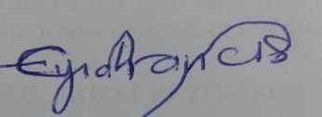

Dr. Francis Eyiah Bediako
Chairman, Match Review Panel
Wednesday, June 16, 2021

